Class 9

Chaprter -2 (2026-27)

Introduction to Java

✅ A. Tick (✓) the correct answer

1. Automatic memory management instructs JVM to ______ unused objects automatically.
Answer: remove ✅

2. In which of the following platform Java runs?
a. Windows Platform
b. Linux Platform
c. Mac OS Platform
d. All of these
Answer: d. All of these ✅

3. Compile button located at the ______ of the code editor window.
Answer: top ✅

4. During compilation process, Java Source code is converted to bytecode which is ______.
Answer: Machine-independent code ✅

5. Applets are codes in Java which are downloaded from a website on a ______.
Answer: Client computer ✅

✅ B. Fill in the blanks

1. Java source code is finally converted to ______ for execution on a specific hardware.
Answer: machine code

2. Memory space is allocated when an ______ is created.
Answer: object

3. ______ is open source application and it is an IDE for beginners.
Answer: BlueJ

4. Java is a platform ______ programming language.
Answer: independent

5. Java does not provide any options of ______ up of data.
Answer: backup

✅ C. Answer the following questions

1. What is BlueJ?
Answer:
BlueJ is an integrated development environment (IDE) used for learning and developing Java programs. It is specially designed for beginners.

2. Write difference between Java Application and Java Applet.
Answer:
Java Application | Java Applet
Runs independently | Runs inside a browser
Requires JVM | Requires browser support
Has main() method | Does not use main()
Used for general programs | Used for web-based programs

3. How do you create a Java project in BlueJ?
Answer:
- Open BlueJ
- Click on Project → New Project
- Enter project name
- Click Create
- Project window opens

4. Write disadvantages of Java.
Answer:
- Slower than languages like C++
- Requires more memory
- No direct hardware control
- GUI is less attractive compared to modern frameworks

5. Who developed Java? What was it initially called?
Answer:
Java was developed by James Gosling at Sun Microsystems.
It was initially called Oak.

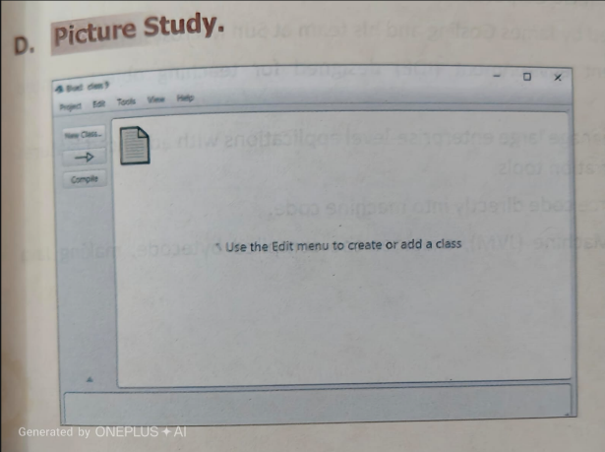

D. Picture Study (MCQs)

1. What is the use of New Class button?
a. To create a class
b. To compile a file
c. To delete a file
d. None of these
Answer: a. To create a class ✅

2. Why compile button is required?
a. To change from source code to machine code
b. To convert from source code to byte code
c. To use Java Compiler
d. Both a and c
Answer: b. To convert from source code to byte code ✅

3. To create a new project, we should click on the __________ button/menu.
a. New Class
b. Compile
c. Arrow symbol
d. Project
Answer: d. Project ✅

4. What is the use of Project icon?
a. To write the source code
b. To keep the byte code
c. To keep the documentation of the project
d. To display the executable file
Answer: c. To keep the documentation of the project ✅

5. After writing the source code we should:
a. Compile the file
b. Execute the file
c. Delete the file
d. Interpret the file
Answer: a. Compile the file ✅

✅ E. Case Study

1. Give one example of OOP language apart from Java.
Answer: C++ / Python

2. Name the persons who developed Java.
Answer: James Gosling and his team

3. Name the software firm from where Java was developed.
Answer: Sun Microsystems

4. What is the full form of WORA?
Answer: Write Once Run Anywhere

5. What are the places where Java is useful?
Answer:
- Mobile applications
- Web applications
- Desktop applications
- Enterprise systems

✅ F. Assertion and Reasoning

1.
Assertion (A): Java was developed in the 1980s by Oracle Corporation.
Reason (R): The original development of Java was led by James Gosling at Sun Microsystems.
Answer: d. A is false, but R is true ✅

2.
Assertion (A): BlueJ is an IDE designed for teaching object-oriented programming.
Reason (R): BlueJ allows developers to create and manage large enterprise-level applications.
Answer: d. A is true, but R is false ✅

3.
Assertion (A): The Java compiler translates Java source code directly into machine code.
Reason (R): The JVM executes bytecode, making Java platform-independent.
Answer: d. A is false, but R is true ✅

Class 9 Chapter 2 (2025-26)
Introduction to Java

A. Tick (✓) the Correct Answer
- Automatic memory management instructs JVM to
  - d. remove unused objects automatically. (✓)
- Java can run on
  - d. All of these (✓)
- Compile button is located at the _____ of the code editor window.
  - b. top (✓)
- During compilation process, Java source code is converted to
  - c. Bytecode (✓)
- Applets are codes in Java which are downloaded from a website on a
  - a. Client computer (✓)

B. Fill in the Blanks
- The extension of Java bytecode is .class.
- Two types of Java programs are Java Application and Java Applet.
- BlueJ is a freely downloadable application.
- Java is a platform-independent programming language.
- The println() method displays the given string along with a line feed.

C. Short Answer Type Questions
- What is BlueJ?
  - BlueJ is an integrated development environment (IDE) designed for Java programming, mainly used for teaching and learning object-oriented programming.
- Write one difference between Java Application and Java Applet.
Feature | Java Application | Java Applet
Execution | Runs on JVM as a standalone program | Runs inside a web browser
Main Method | Requires main() method | Does not require main() method
- How do you create a Java project in BlueJ?
  - Open BlueJ → Click on Project → Select New Project → Enter a name → Click OK.
- Write any two disadvantages of Java.
  - Slower execution speed compared to languages like C++.
  - Consumes more memory due to JVM and garbage collection.
- Who developed Java? What was it initially called?
  - Java was developed by James Gosling at Sun Microsystems.
  - It was initially called Oak.

